**Name: Matthew David Lyon**

**Matric No.: HCSF/23/0079**

**Department: Computer Science**

**Level: HND 1**

**Course Code: COM 322**

ASSIGNMENT

1. THE UNIX SHELL

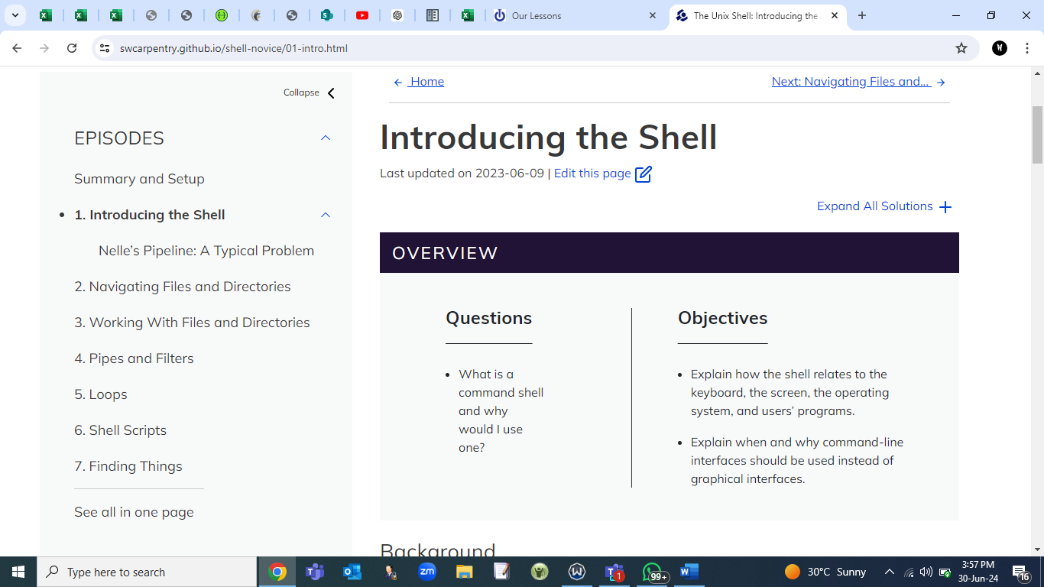

1. VERSION CONTROL WITH GIT

